Amir Abbas Moumeni Zadeh – CA2 Report – SID : 810101529

1)

We should build a 2-bit adder with carry in and carry out.

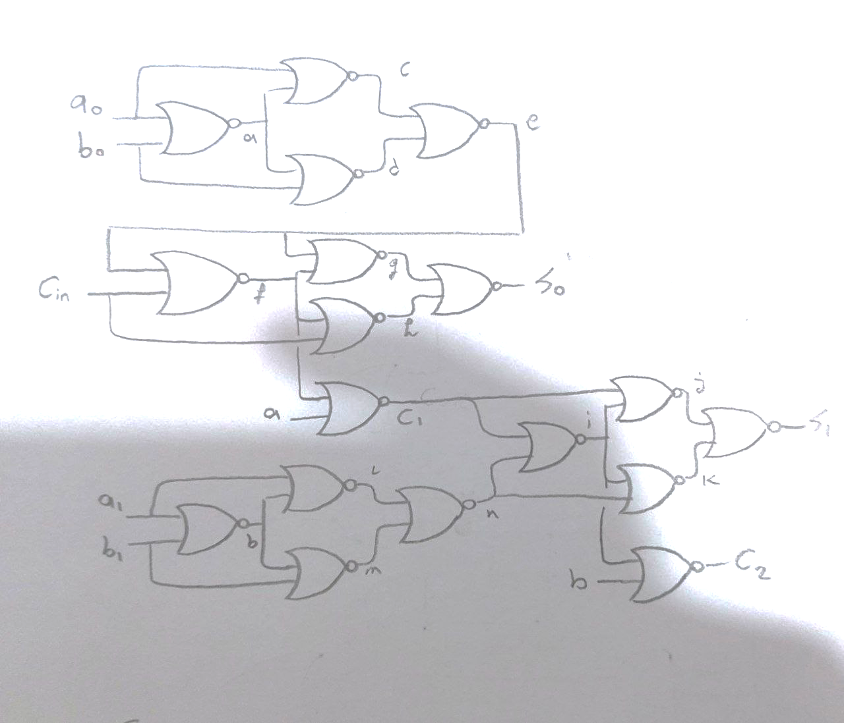this is the original 2-bit adder but we have to convert it to all NOR gates.

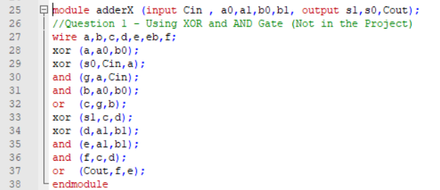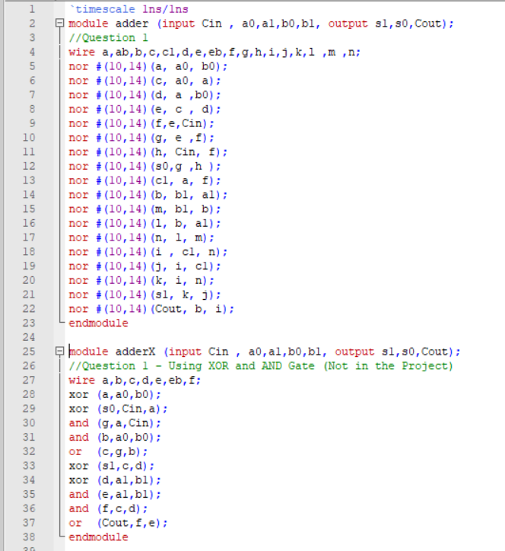

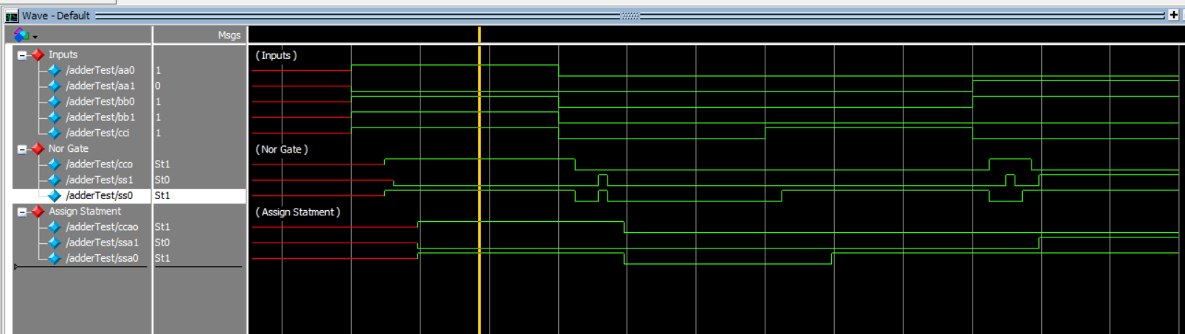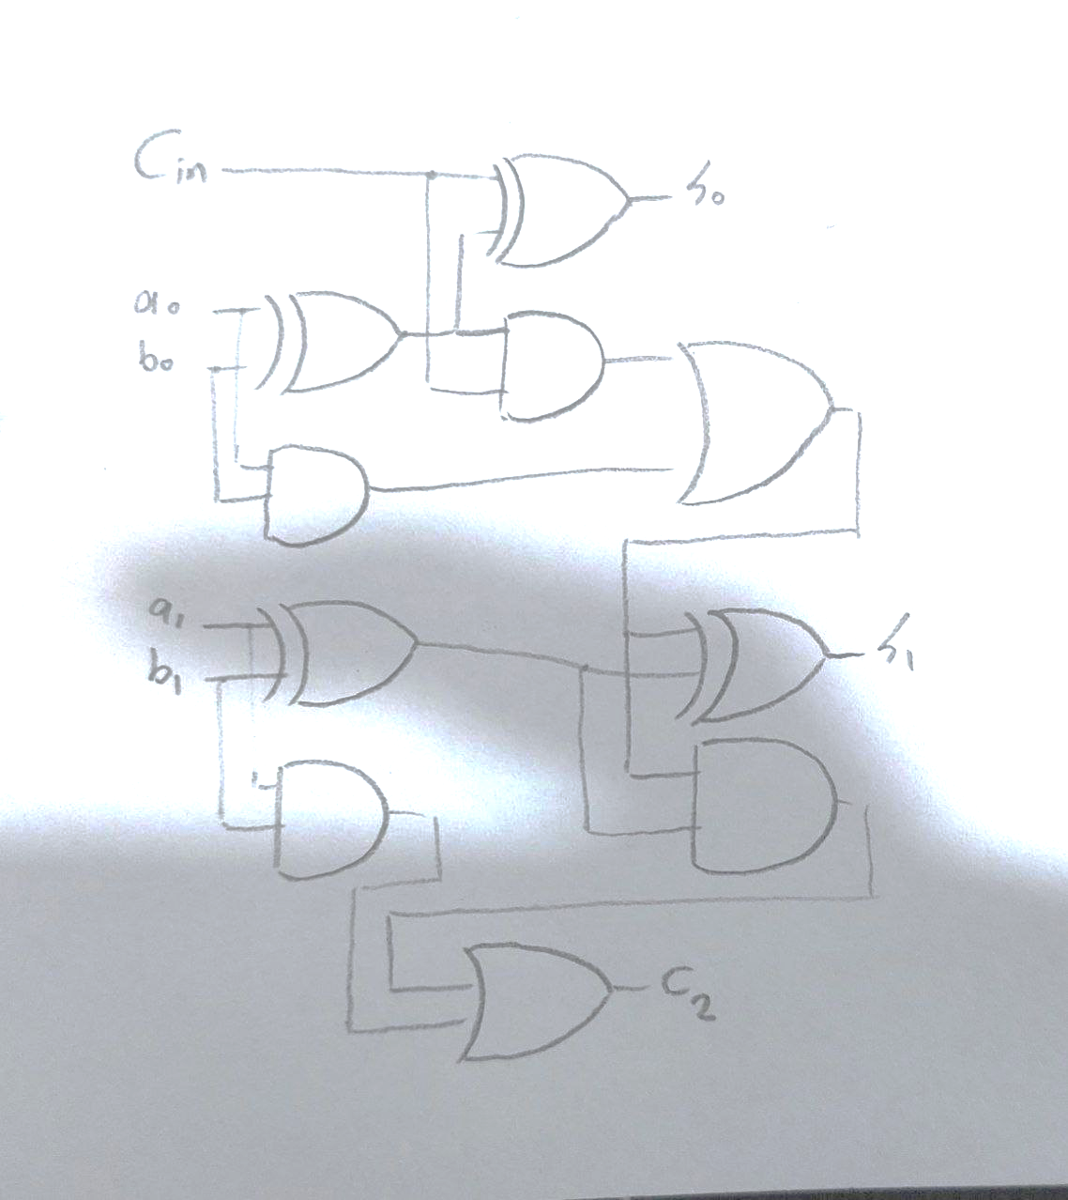





S0 Longest Path : 14 + 10 + 14 + 10 + 14 + 10 = 72ns

S1 Longest Path : 14 + 10 + 14 + 10 + 14 + 10 +14+10 = 96ns

C2 Longest Path : 14 + 10 + 14 + 10 + 14 + 10 +14= 86ns



3) for implimenting this circuit with MUX we can first impliment AND, OR, XOR with MUX and then it will be easy.

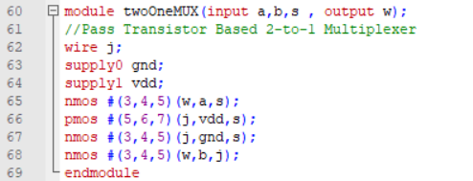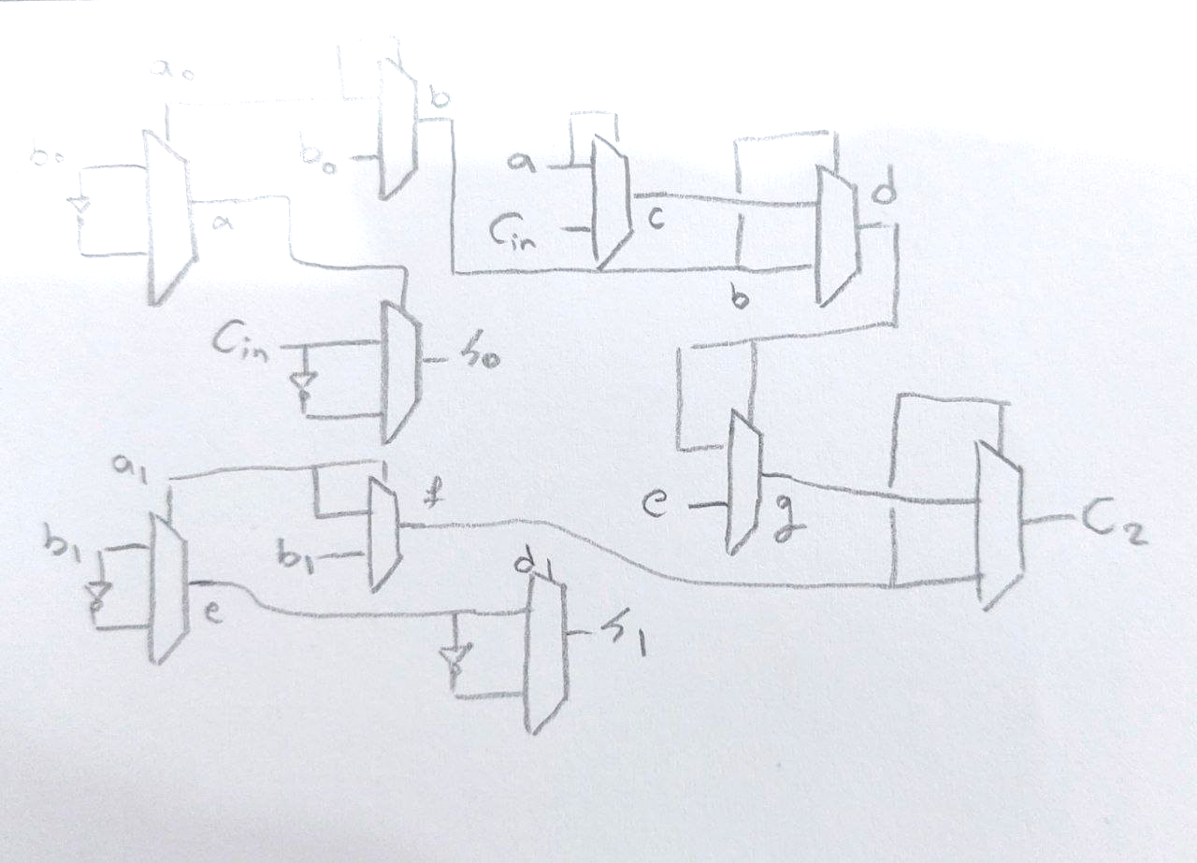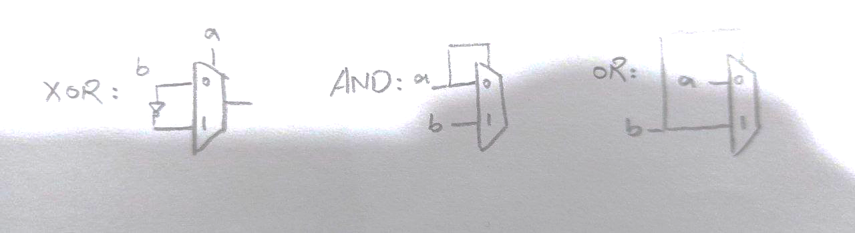5)

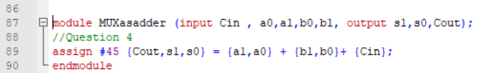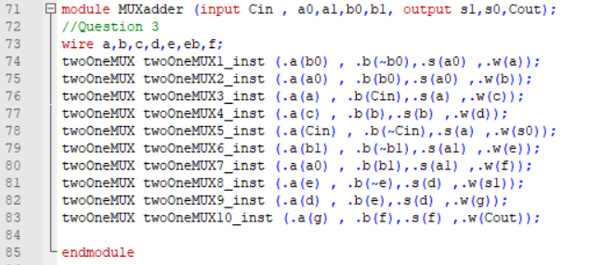

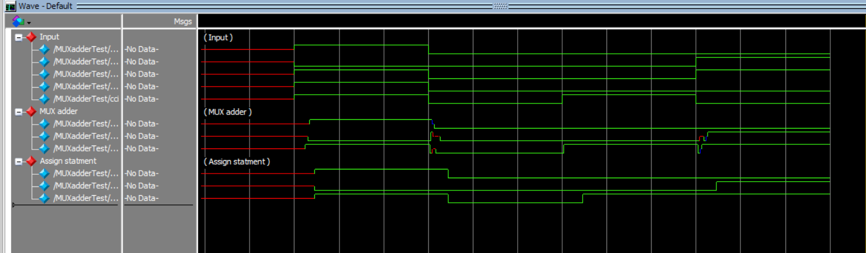

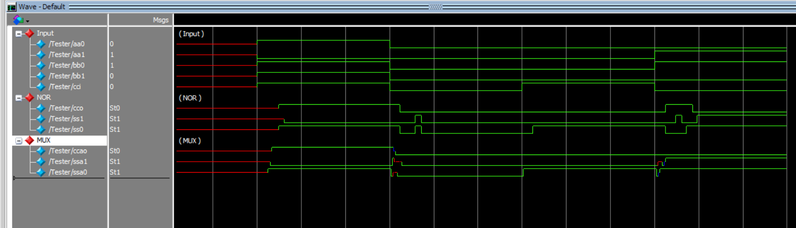5)

7)

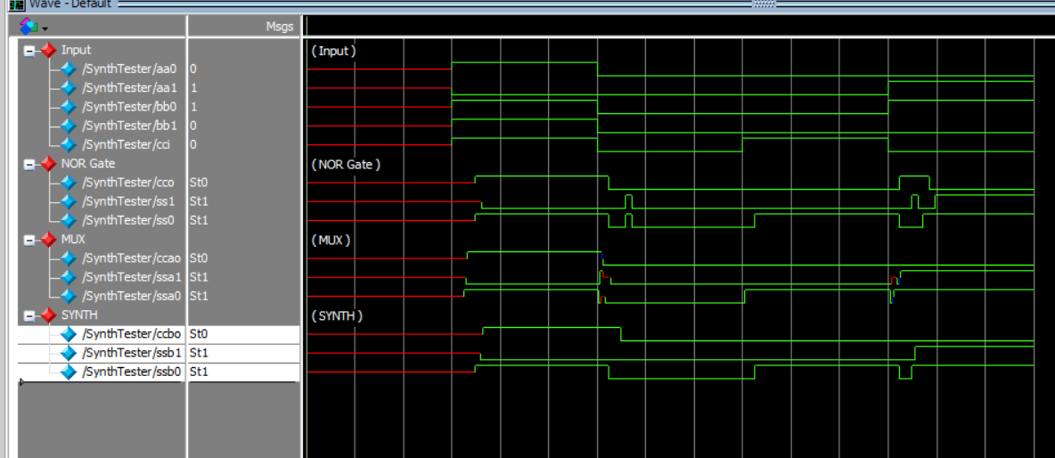

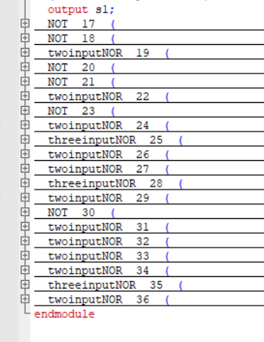11 Two input NOR Gates

3 Three Input NOR Gates

6 Invertors